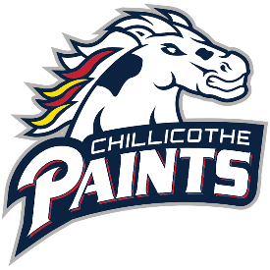
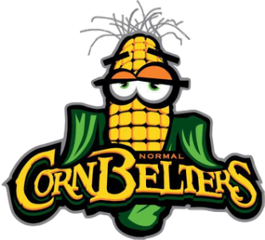
Report: Chillicothe Paints (5-4)
Prepared for: Normal Cornbelters (4-5)
As of: 06/06/2025
REX Overview
Record: 5-4 (3-1 home, 2-3 away)
Run differential: +19 (60 runs scored, 41 runs allowed)
Team offensive stats: .252/.416/.361 (Batting average/on-base percentage/slugging percentage)
Team ERA: 3.74 (2nd in Prospect League)
Key Takeaways
- Watch for Cam Gravelle in the box and on the basepaths, Alex Bemis is a power threat
- High team walk rate, 2nd in PL in OBP
- Paints lead PL in SB/CS (39/11), they will likely try to run a lot
Paints Offense – Most Recent College Season
# | Name | School | PA | H | HR | BB | SO | AVG | OBP | SB
1 | Alex Bemis | Gannon (NCAA D2) | 191 | 52 | 8 | 23 | 29 | .311 | .415 | 14
3 | Cam Gravelle | Toledo (NCAA D1) | 82 | 15 | 1 | 4 | 13 | .208 | .247 | 1
4 | Zack Henderson | Indiana State (NCAA D1) | 44 | 11 | 0 | 6 | 8 | .297 | .409 | 3
5 | Jacob Buysse | West Virginia State (NCAA D2) | 35 | 4 | 0 | 2 | 15 | .121 | .171 | 0
6 | Mitchel Szymczak | Lake Erie (NCAA D2) | 175 | 32 | 6 | 25 | 28 | .218 | .343 | 6
7 | Micah Geise | Lake Erie (NCAA D2) | 148 | 26 | 2 | 23 | 38 | .228 | .388 | 10
8 | Carson Cox | Indiana State (NCAA D1) | 14 | 1 | 0 | 1 | 6 | .077 | .200 | 0
11 | CJ Richmond | Purdue (NCAA D1) | 140 | 25 | 5 | 17 | 38 | .221 | .369 | 2
13 | Colin West | Baldwin Wallace (NCAA D3) | 137 | 39 | 2 | 19 | 12 | .364 | .467 | 7
15 | Mason McManus | Erskine (NCAA D2) | 86 | 19 | 2 | 8 | 20 | .264 | .369 | 1
17 | Michael Patellis | Tiffin (NCAA D2) | 37 | 4 | 0 | 3 | 19 | .118 | .189 | 0
18 | Jackson Boles | Cuyahoga CC (NJCAA) | 195 | 64 | 10 | 26 | 15 | .427 | .531 | 39
21 | CJ Carmichael | Frostburg State (NCAA D2) | 188 | 47 | 1 | 24 | 23 | .305 | .404 | 15
23 | Zane Vitense | Ohio Wesleyan (NCAA D3) | 121 | 37 | 0 | 8 | 11 | .339 | .397 | 0
26 | Nate Hill | Toledo (NCAA D1) | 36 | 4 | 0 | 3 | 20 | .121 | .194 | 0
32 | Tyler Stone | Kean (NCAA D3) | 241 | 66 | 4 | 32 | 23 | .340 | .452 | 10
37 | Justin Teixiera | Kean (NCAA D3) | 230 | 51 | 1 | 35 | 27 | .294 | .420 | 14
39 | Justin Gorski | Miami (NCAA D1) | 29 | 4 | 0 | 4 | 8 | .190 | .320 | 1

Hill – stats are from 2024
Vitense listed as pitcher, also has 15 PA in PL this season
REX Pitching – Most Recent College Season
# | Name | Throws | School | ERA | IP | H | ER | HR | BB | SO | Last PL Outing, NP
2 | Kale Wemer | R | Purdue (NCAA D1) | -- | -- | -- | -- | -- | -- | -- | RP 6/3, 25
9 | Tyler Mendez | R | Brookdale CC (NJCAA) | 4.45 | 32.1 | 27 | 16 | 5 | 19 | 41 | RP 6/4, 47
10 | Matt Moscarino | R | Baldwin Wallace (NCAA D3) | 2.61 | 48.1 | 39 | 14 | 3 | 13 | 35 | SP 6/3, 96
12 | Trent Hedges | R | Tiffin (NCAA D2) | 5.52 | 17.0 | 17 | 9 | 1 | 7 | 22 | CP 6/3, 15
14 | Dylan Lloyd | R | Hanover (NCAA D3) | 7.24 | 46.0 | 50 | 37 | 2 | 28 | 45 | SP 5/31, 95
16 | Will Rodriguez | R | Hanover (NCAA D3) | 12.32 | 19.0 | 33 | 26 | 3 | 16 | 18 | RP 6/5, 8
19 | AJ Dallmayer | R | Lake Erie (NCAA D2) | 17.47 | 5.2 | 7 | 11 | 2 | 12 | 7 | RP 6/1, 54
23 | Zane Vitense | R | Ohio Wesleyan (NCAA D3) | 24.75 | 4.0 | 12 | 11 | 1 | 2 | 1 | RP 6/5, 25
28 | Gavin Beuter | R | Purdue (NCAA D1) | 6.23 | 30.1 | 41 | 21 | 5 | 10 | 21 | SP 5/30, 75
31 | Luke Walter | R | Otterbein (NCAA D3) | 4.63 | 35.0 | 41 | 18 | 2 | 26 | 22 | SP 6/4, 70
33 | Branin Seibert | L | Wayland Baptist (NAIA) | 5.67 | 60.1 | 63 | 38 | 13 | 51 | 64 | RP 6/5, 21
34 | JT Fabian | L | West Virginia State (NCAA D2) | 4.61 | 54.2 | 42 | 28 | 5 | 45 | 44 | SP 6/1, 62
36 | Cal Chase | R | Kean (NCAA D3) | 5.66 | 20.2 | 19 | 13 | 1 | 10 | 14 | None
38 | AJ McAninch | R | Marshall (NCAA D1) | 0.00 | 5.0 | 2 | 0 | 0 | 4 | 4 | RP 6/4, 29
40 | Vince Waterman | L | Kent State (NCAA D1) | -- | -- | -- | -- | -- | -- | -- | None
41 | Zach Neville | R | Miami (NCAA D1) | 0.00 | 0.1 | 0 | 0 | 0 | 1 | 0 | None
52 | Alex Caudill | R | Lake Erie (NCAA D2) | 4.08 | 64.0 | 38 | 29 | 2 | 48 | 89 | SP 6/5, 84
74 | Mahoney Daunic | R | Denison (NCAA D3) | 3.60 | 5.0 | 3 | 2 | 0 | 2 | 3 | None
76 | Christian Pareja | R | Kean (NCAA D3) | 2.99 | 69.1 | 65 | 23 | 6 | 30 | 47 | None

Red fill – ineligible to pitch on 6/6
Possible starter: Gavin Beuter – 5.0 IP 5 H 0 ER 4 SO vs. REX on 5/30
Possible starter: Dylan Lloyd – 6.0 IP 1 H 1 ER @ Johnstown on 5/31

This Season Standouts
Alex Bemis - .280/.455/.600 (avg/obp/slg) 2 HR in 33 PA
Cam Gravelle - .417/.576/.500 13 SB in 34 PA
Gavin Beuter – 0.00 ERA 4 K in 5.0 IP
Trent Hedges – 0.00 ERA 6 K in 5.0 IP

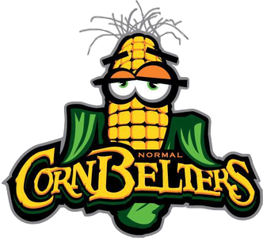

Report prepared by Cam Cischke, Analytics Intern

